Using Infofinder i to find your bus assignment, times, and school of attendance: Step By Step Instructions
- Using your web browser to go to grandviewc4.net
- Click on families and then stops and boundaries:
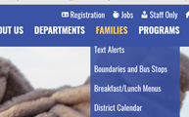
- This will bring up the infofinder i page. Simply type in your address and then it will populate the bus information or walk area information.
- For High Grove families please make sure you are looking for the correct program (Title One, ECSE, Head Start) your child attends along with AM or PM session.
- If you have trouble navigating the system, please call your child’s school or the transportation office. See Example below.
